- Develop a C program using fork() that creates a parent and child process. Display the Process ID (PID), Parent Process ID (PPID), and process states at different stages of execution.
Design an experiment to observe process state transitions (Ready, Running, Waiting, Terminated) using Linux monitoring tools such as ps, top, and /proc. Document the observations.
OUTPUT :
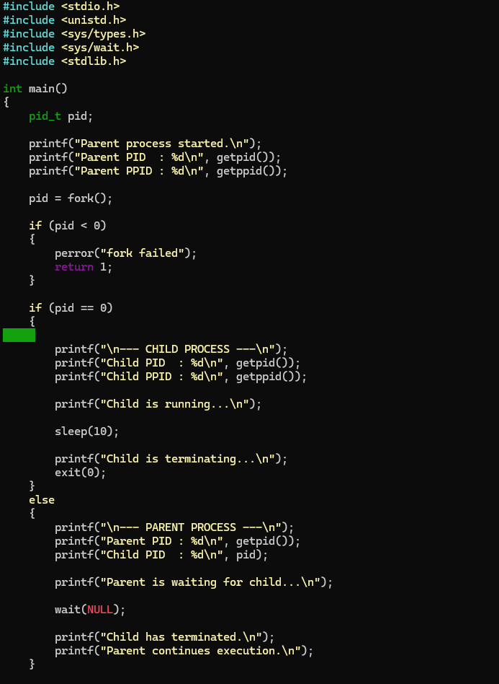
:
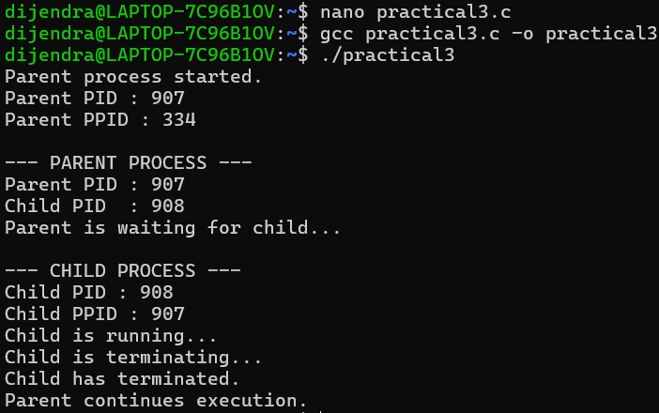

- Write a C program where a parent process creates multiple child processes and synchronizes their completion using wait() and waitpid(). Compare the behavior of both functions.

Create a scenario where a child process becomes a zombie process. Investigate the process table and then modify the program to eliminate zombie processes using proper synchronization techniques.
OUTPUT :
